BINFLOW

Full Stack Development Lab Project

Submitted

in partial fulfilment of the requirements for completion of
Bachelor of Technology VI ^{th} Semester
in
Computer Science Engineering
by
A.HEMANTH DATTA (23261A0567)
and
T.M. NIKILESH KUMAR (23261A05B9)
Under the guidance of

Mr. Y .Pavan Narasimha Rao
(Assistant Professor)


Department of Computer Science and Engineering,
MAHATMA GANDHI INSTITUTE OF TECHNOLOGY,
GANDIPET, HYDERABAD-500 075, INDIA.
2025-2026
MAHATMA GANDHI INSTITUTE OF TECHNOLOGY
(Affiliated to Jawaharlal Nehru Technological University Hyderabad)
Gandipet, Hyderabad-500 075, Telangana (India)


CERTIFICATE

This is to certify that the Full Stack Development Lab Project entitled “Binflow”, is being submitted by Mr.A.Hemanth Datta bearing Roll No: 23261A0567 and Mr.T.M.Nikilesh Kumar bearing Roll No: 23261A05B9 in partial fulfillment for completion of Bachelor of Technology vi Semester in Computer Science and Engineering to Mahatma Gandhi Institute of Technology is a record of bona-fide work carried out by him under our guidance and supervision. The results embodied in this project have not been submitted to any other University or Institute for the award of any degree or diploma.

Project Coordinator Head of the Department
Mr. Y . PAVAN NARASIMHA Dr. C.R.K Reddy
Asst. Professor, Dept. of CSE Professor, Dept. of CSE

ABSTRACT

BinFlow is a web-based Waste Collection Complaint Management System developed to streamline the process of reporting, tracking, and resolving waste-related issues in urban areas. The system provides a centralized platform where citizens can submit complaints by uploading images and sharing GPS-based location details. Administrators can monitor complaints through interactive dashboards and maps, assign field workers, dispatch collection vehicles, and analyze complaint trends using graphical reports. Workers receive assigned tasks, navigate to complaint locations, update progress, and mark complaints as resolved after completion.
The application is built using the MERN stack (MongoDB, Express.js, React.js, and Node.js) and incorporates modern technologies such as JWT authentication, Cloudinary image storage, and React-Leaflet maps. Every complaint status update is recorded through an audit logging mechanism to ensure transparency and accountability. The system reduces dependency on manual complaint handling methods, improves response times, and enhances operational efficiency. BinFlow demonstrates how digital technologies can be effectively used to support smart city initiatives and improve urban sanitation management.

2.INTRODUCTION

Waste management is one of the major challenges faced by modern cities due to rapid urbanization and population growth. Traditional methods of reporting waste-related issues often rely on phone calls, manual records, or informal communication, which can lead to delays, poor tracking, and inefficient complaint resolution. To address these challenges, BinFlow was developed as a web-based Waste Collection Complaint Management System that provides a centralized platform for citizens, administrators, and field workers.
The system enables citizens to report waste-related complaints by uploading images and sharing GPS-based location information. Administrators can monitor complaints through interactive dashboards, assign workers, dispatch collection vehicles, and analyze complaint trends using maps and analytics. Workers can view assigned tasks, navigate to complaint locations, and update complaint statuses after completing their work. Built using the MERN stack, BinFlow improves transparency, accountability, and operational efficiency in waste management. The platform aims to support cleaner urban environments and contribute to the development of smart and sustainable cities.

IMPLEMENTATION

The implementation of BinFlow was carried out using the MERN stack, consisting of MongoDB, Express.js, React.js, and Node.js. The frontend was developed using React and Vite to provide a responsive and user-friendly interface for citizens, administrators, and workers. React Router was used for navigation, while Axios handled communication with backend APIs. Interactive maps were integrated using React-Leaflet and OpenStreetMap to support location-based complaint reporting and tracking.
1. MERN Stack Development
The BinFlow application was developed using the MERN stack, which consists of MongoDB, Express.js, React.js, and Node.js. This technology stack enables efficient development of a scalable and full-featured web application.
2. Separate User Dashboards
Different dashboards were designed for Citizens, Administrators, and Workers. Each dashboard provides role-specific features and access permissions to improve usability and workflow management.
3. Authentication and Authorization
JWT authentication was implemented to secure user sessions and protect sensitive data. Role-based access control ensures that users can only access features assigned to their roles.
4. Database Management
MongoDB Atlas was used as the cloud database to store user details, complaints, and status logs. Mongoose schemas were used to manage and organize the data efficiently.
5. Map and Location Tracking
React-Leaflet and OpenStreetMap were integrated to allow users to submit complaints with GPS coordinates. Administrators and workers can easily locate complaint areas through interactive maps.
6. Complaint Submission System
Citizens can submit complaints by providing details, uploading images, and sharing their location. This ensures accurate reporting and helps authorities identify issues quickly.
7. Image Upload Integration
Multer middleware was used to handle image uploads, while Cloudinary was used for cloud storage. This allows secure and efficient storage of complaint images.
8. RESTful API Development
REST APIs were developed using Express.js to manage user authentication, complaint handling, worker assignments, and status updates. These APIs enable smooth communication between the frontend and backend.
9. Complaint Lifecycle Management
The system follows a structured workflow from complaint registration to closure. Statuses such as Reported, Assigned, In Progress, Resolved, and Closed help track complaint progress effectively.
10. Analytics Dashboard
An analytics module was implemented to display complaint statistics, trends, and category-wise reports. These insights help administrators monitor performance and make informed decisions.
11. Audit Logging System
Every complaint status update is recorded in a Status Log collection. This provides transparency, accountability, and a complete history of actions performed on each complaint.
12. System Testing
The application was tested for authentication, database operations, complaint processing, image uploads, and map functionality. Testing ensured that all modules work correctly and reliably.

4. FLOW CHART

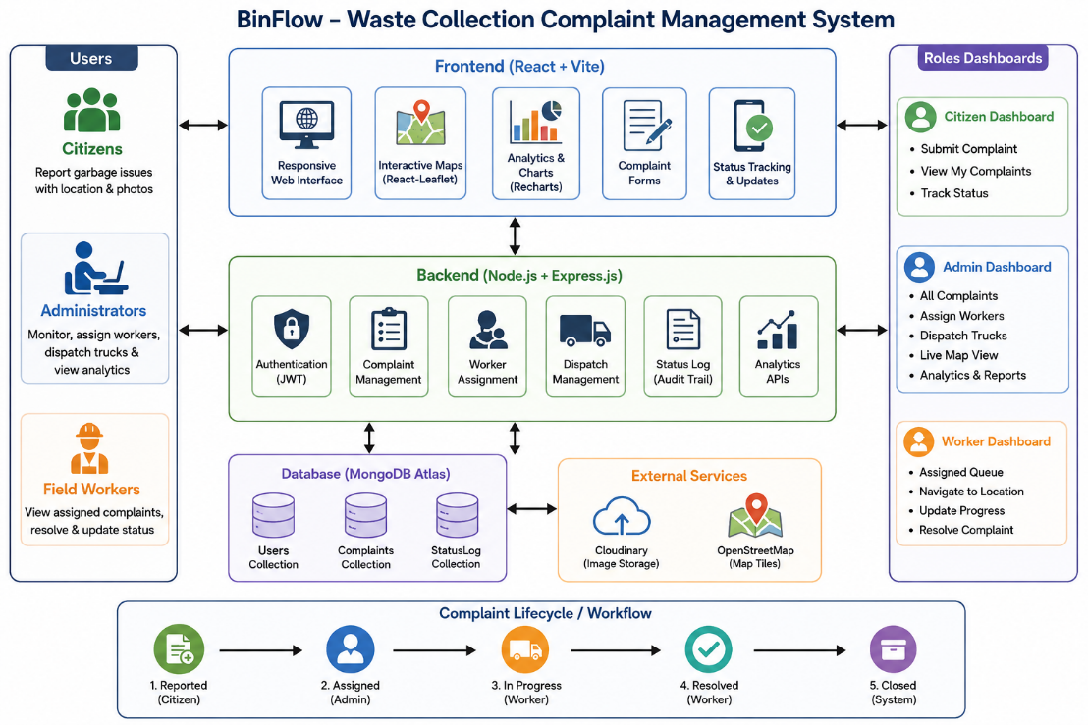
Figure 4.1: System Architecture and Workflow of BinFlow Waste Collection Complaint Management System

The flow chart of the BinFlow Waste Collection Complaint Management System represents the complete workflow involved in managing waste-related complaints. The process begins when a citizen registers or logs into the system and submits a complaint by providing details, uploading an image, and sharing the complaint location through GPS. The complaint is then stored in the database and becomes visible to the administrator. After reviewing the complaint, the administrator assigns a worker and dispatches the task with necessary instructions and estimated arrival time. The assigned worker receives the complaint details, navigates to the location, and updates the complaint status as work progresses. Once the waste issue is resolved, the worker marks the complaint as resolved, and the administrator verifies and closes the complaint. Throughout the process, all status changes are recorded in the system for transparency and accountability. The collected complaint data is also used to generate reports and analytics, helping authorities monitor performance and improve waste management services.

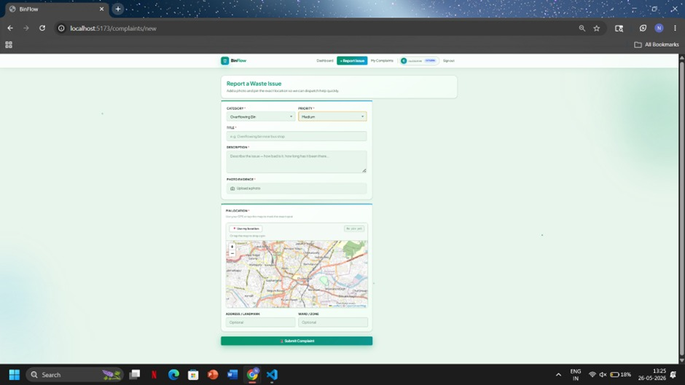
5. RESULTS

Fig 5.1: Waste Complaint Reporting Page (BinFlow).

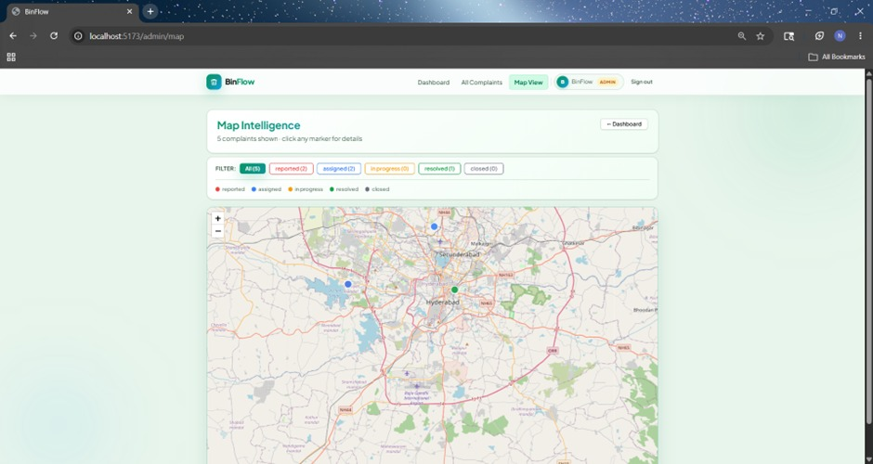
The figure illustrates the complaint registration module of the BinFlow system. Users can report waste-related issues by entering complaint details, uploading photographic evidence, selecting the issue location on a map, and submitting the complaint to the authorities for timely resolution.

Fig 5.2: Map Intelligence Dashboard for Complaint Monitoring

The figure illustrates the Map Intelligence dashboard of the BinFlow system. It visualizes complaint locations on an interactive map and categorizes them based on their current status. This feature assists administrators in monitoring waste management activities, tracking complaint progress, and making informed decisions for efficient service delivery.

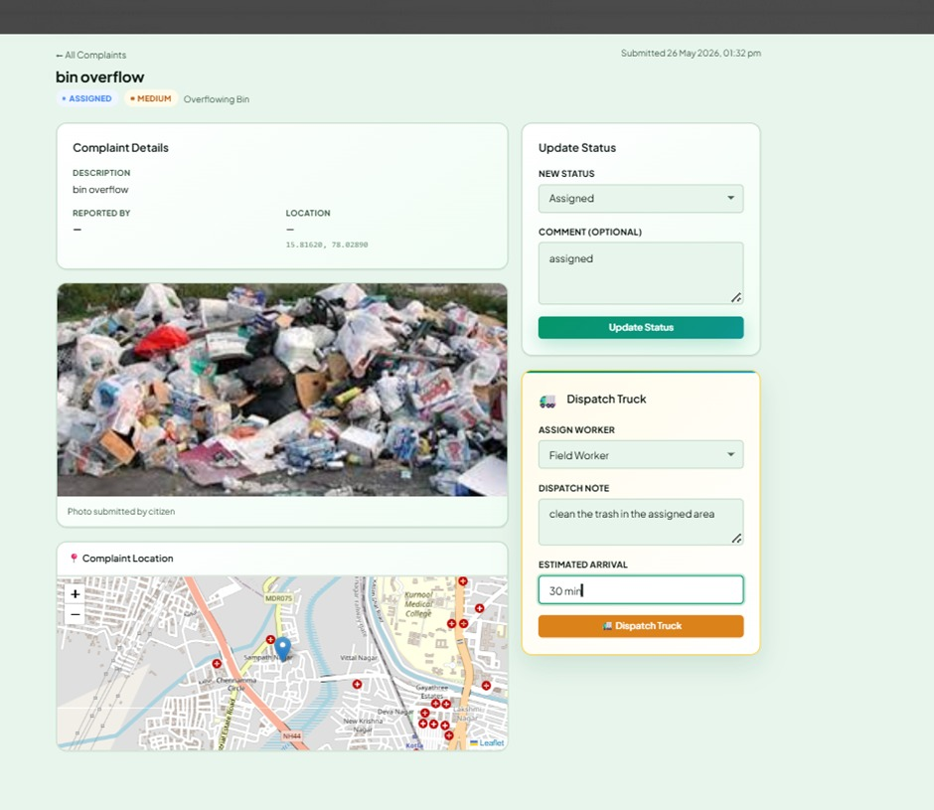

Fig 5.3: Complaint Management and Truck Dispatch Interface in BinFlow

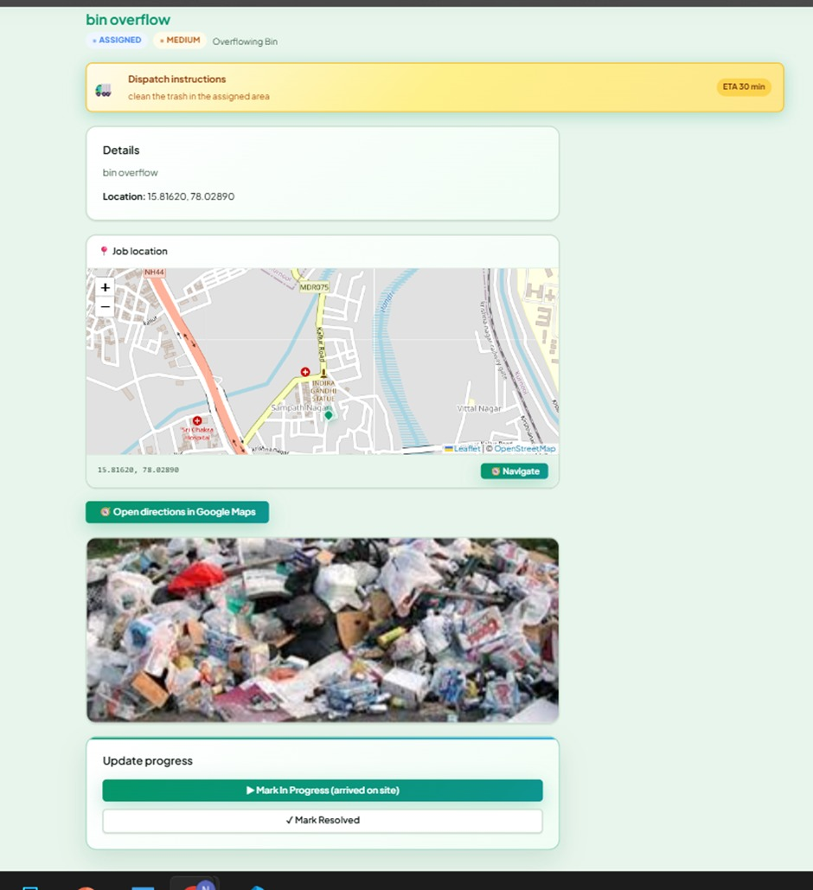
The figure illustrates the complaint tracking and dispatch management module of the BinFlow system. Administrators can review complaint details, verify uploaded evidence, update complaint status, assign field workers, and dispatch collection vehicles to ensure timely resolution of waste management issues.

Fig 5.4: Field Worker Task and Progress Tracking Interface

The figure illustrates the field worker interface in the BinFlow system. It provides complaint details, navigation assistance, photographic evidence, and task progress controls. This module helps field workers efficiently locate waste issues, perform cleanup operations

6. CONCLUSION

The BinFlow Waste Collection Complaint Management System provides an effective digital solution for managing waste-related complaints in a transparent and organized manner. The system enables citizens to report issues easily through image uploads and GPS-based location tracking, while administrators can efficiently monitor complaints, assign workers, and analyze performance through dashboards and maps. Workers can receive assigned tasks, update complaint statuses, and ensure timely resolution of reported issues.
Developed using the MERN stack, the application integrates modern technologies such as JWT authentication, Cloudinary storage, and React-Leaflet mapping services to provide security, reliability, and scalability. The implementation of role-based access control and audit logging enhances accountability and ensures proper workflow management. By reducing manual intervention and improving communication among stakeholders, BinFlow helps minimize complaint resolution time and improves municipal waste management efficiency. Overall, the project demonstrates how modern web technologies can be utilized to support smart city initiatives and create cleaner, healthier urban environments.

